Capstone 2 - US Used Car Sales Predictive Model

1. **Objective:**

To develop a predictive model that automates the domestic used car sales market appraisal and estimation/evaluation process. The main driving force behind the development of this model is to minimize laborious efforts that go into researching used car sales data (e.g. what can I get for a 2011 toyota camry SE?) by deploying a model built using historical data with the ability to consume new data (leveraging Bayesian principles – ideal, future state model).

1. **Assumptions and Exclusions:**

*B1. Key Assumptions/Comments 🡪*

* Prices are set by a free market (consumer demand versus available supply)
* Some potential key features were missing from this analysis: color, general condition of the car (ordinal scaling), damage/vehicle inspection history, etc.
* Accounted for missing values and erroneous/extreme data points after visualizing distributions of each variable

*B2. Key Exclusions* 🡪

* Price data was missing from about 9.24% of the dataset; these observations were dropped as a result
* Some features in the original dataset were excluded due to them having an assumed low impact: 'id', 'vin', 'stock_no', 'street', 'seller_name', 'zip', 'city'
  + The vin and stock number are too granular for this analysis and would result in a ridiculously high dimensionality
  + I left the ‘state’ categorical variable to incorporate the spatial context; this helps to better understand the geographical impact on price
  + The ‘seller_name’ was not considered fundamental for this analysis, as I’m looking to find the true demand for a given car irrespective of what a specific entity sells said car for

1. **Data Wrangling, EDA and Preprocessing:**

*C1. Data Collection and Wrangling 🡪*

* Imported the original US Car sales dataset (from Kaggle.com)
  + 1) the original dataset contained 7,104,304 used car sales transactions and incorporated 21 features (see fig 1 on the next page)
    - Excluded 7 features as mentioned in section B2
  + 2) manually added in the manufacturer origin (country)

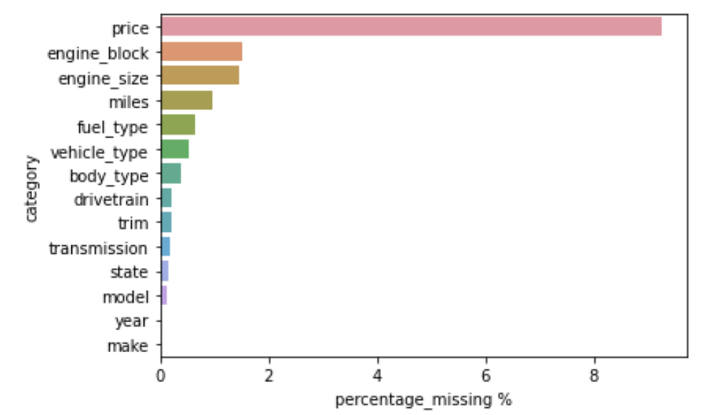

**Fig. 1** – Original Dataset Features **Fig. 2** – Missing data

*C2. Initial Inspection of numerical distributions 🡪*

**Figs. 3 and 4** – Price Distribution (left) and Mileage Distribution (right)

**Fig. 5** – Year of Manufacturer Distribution **Fig. 6** – Engine Size Distribution

**Fig. 6** – Numerical Feature Correlation

*C3. Manual inspection of the values for categorical data and cleanup 🡪*

* Quite a bit of manual effort went into standardizing the naming conventions for the makes, models, fuel type and trim (example shown below)

**Fig. 7** – Model cleanup

**Fig. 8** – Top models sold by decade produced

**Fig. 9** – Trim cleanup

*C4. Additional EDA 🡪*

* Because there were quite a few categorical features, it was important to visualize their distribution/impact across the dataset in a variety of ways; mainly, how did the trend changed over time
* As one would have expected, the newer cars (>2015) yielded a higher sale price, but what was interesting is how the FWD was continuously the lowest while the RWD/4WD median price changed based on the manufactured year
* Notice how the lowest valued cars appear to be made from 2000-2005; why could this be? Is it purely a supply v demand (meaning, most cars older then 15 years are kept in pristine condition/low mileage and are coveted by car enthusiasts) or is there a theme related to how a car is manufactured (do people just generally like the look/feel of cars in the 80s/90s moreso than the early 2000s)?
  + I believe the prevailing phenomena is the former of what was outlined above. There are significantly less cars sold that were produced before 2000 (see **Fig 12** on the next page)
  + Hence, there were 1787x more cars sold that were produced from 2011-2020 when compared to ones produced from 1980-1990

**Fig. 10** – Median Price per Drivetrain Type by Year **Fig. 11** – Median Price per Transmission Type by Year

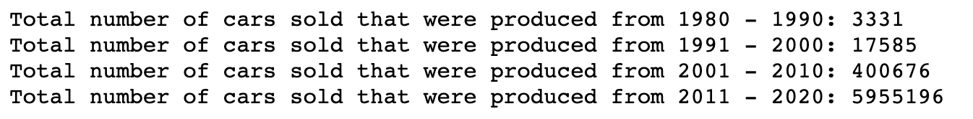

**Fig. 12** - # of cars sold per manufactured decade

* For the next investigated step, I cleaned up the fuel types, and consolidated the naming conventions
* After the cleanup, the distribution of counts/observations of the various fuel types can be seen in **Fig. 13,** shownbelow
* Additionally, I wanted to visualize the relationship between price, fuel type and year of manufacture to get a better understanding of how the market has changed over time

**Fig. 13** – Fuel Type Counts  **Fig. 14** – Price based on Fuel Type and Year

* As part of the analysis, I included the “country of origin” feature to better visualize how price is affected by the manufacturer’s country; as one would expect, Italy, Germany and England are consistently higher than the other nations
* Older foreign cars appear to be more valued/coveted by car enthusiasts

**Fig. 15** – Country of Origin, Price and Year of Manufacture

**Fig. 16** – Price v Miles by Make

* The scatter plot shown above is a bit busy, but it uses a log scale for the x axis (price)
* The emphasis on this plot is to identify some outliers, as mileage and price are correlated
  + Notice how some cars > $100k while sporting >150,000 miles; this is quite compelling and shows that some models have been deemed to warrant a heavy premium compared to the population as a whole
* The second scatter plot, shown below, brings the data up a few levels
  + Here you can see that Italian models are typically higher in price and lower in mileage when compared to the other countries of origin
  + Swedish cars are typically the cheapest and have quite a bit of mileage

**Fig. 17** – Price v Miles by Country of Origin

**Fig. 18** – Closer look at Italian makes

**Fig. 19** – Closer look at German makes

*C5. Preprocessing 🡪*

* After dropping the rows that had no associated price, I had quite a few variables with missing values (see **Fig. 20** below)
* Initially, I planned on using the missingforests imputation algorithm (or something a bit more intelligent), but it required too much time and was computationally expensive
  + Realistically, because the % of values missing is so small, a simple imputation approach is sufficient
* Because my intention was to use a tree-based regressor or a neural network, it made sense to just fill the missing categorical values with “missing” and the missing numerical values with something that would identify them as being different: miles = -10,000, year = 1900, engine_size = 1.0

**Fig. 20** – remaining missing values

**Fig. 21** – imputing the rest of the missing values

* After completing the imputation of all missing values, I went ahead and created a custom dummy transformer that would handle the high dimensionality encoding requirements (fig 22 on the next page); this was necessary for testing out some of the regressors (RandomForestRegressor, LinearRegressor, XGBRegressor)
* Once the categorical variables were successfully encoded, I was looking to scale the numerical variables
* The aformentioned steps were part of the pre_pipeline, that when combined with the model, would complete the full_pipeline as shown in Fig. 23 on the next page

**Fig. 22** – Custom Dummy Encoder

**Fig. 23** – Initial Pipeline

1. **Modelling:**

*D1. Initial Discovery Phase 🡪*

* Based on preprocessing steps defined in section C5, I was able to test 4 different algorithms on the training data (80/20 split)
  + The caveat here is that because my categorical variables created a wide encoded dataset, I was forced to exclude the trim and model features to run some of the more complex models
  + This was not ideal and led me to focusing my efforts on utilizing the LGBMRegressor, as it has more capabilities for handling higher dimensions with ease
  + The RidgeRegressor failed due to a lack of memory available
* The MSE scores of the initial models were as follows:

|  |  |  |
| --- | --- | --- |
| **Algorithm:** | **Timing to run model:** | **MSE:** |
| XGBRegressor | 2.97 hours | 28,930,331.50 |
| LinearRegressor | .131 hours | 91,910,606 |
| LGBMRegressor | .043 hours | 33,920,875.33 |
| RandomForestRegressor | .86 hours | 195,518,841 |

* Based on the above table, it appears as though the XBGRegressor could be the winner; after considering the necessary computational requirements and model flexibility, the LGBMRegressor was a more applicable algorithm
  + The main reason for going with the LGBMRegressor over the XGBRegressor was the native capabilities of the LGBMRegressor to effortlessly handle categorical variables without having to encode; this allowed me to incorporate all pertinent features instead of having to drop the model and trim features because of resource limitations

*D2. Baseline Model: LGBM Regressor (not optimized) 🡪*

**Fig. 24** – Training Data Performance

* Ideally, I would’ve like to use the RSMLE (log error) metric, but the y_pred forecasted some negative values and the RSMLE metric cannot handle negative values
  + Presumably because of the imputation method
  + Now, there are some simple solutions to get around the error, but the combination of MSE, MAE and sq_rt(MSE) was sufficient for tuning

**Fig. 25** – Training Model Feature Importance

* Good thing I kept the model and trim categories, as those appear to be the most important after fitting and evaluating the model on the training data; intuitively, this makes sense based on the EDA
  + Why? Because as I discussed in the EDA portion of the analysis, you have some high-mileage cars that yield incredibly high prices based on their “model” and type of model/ “trim”

*D3. Optimized Model: LGBM Regressor (tuning the hyperparameters) 🡪*

* To tune the base model, I went ahead and leveraged the sklearn RandomizedSearchCV package
* The hyperparameters in focus are shown below in **Fig.** 26

**Fig. 26** – RandomizedSearchCV Hyperparameter tuning

**Fig. 27** – Timing, Best Parameters and Scoring of the Tuned Model

**Fig. 28** – Updated Feature Importance

* The base model had a SQRT MSE of 5,824.16 while the tuned model was 3,298.03; that marks a significant improvement
* The only thing left to do is to apply the tuned model to the test dataset after scaling the test dataset

**Fig. 29** – Test Data Scores and Visualizing 1000 Predictions

* The test dataset scored a little bit lower than the training data, but it is clear that the model is generic enough to be applied/utilized on unseen data

1. **Lessons Learned and Comments:**

* This project served as a great introduction into predictive modelling via leveraging regression techniques/algorithms
* Potential future improvements include the following:
  + This model can be improved upon by incorporating a bit more detail/features as described in the introductory section
  + With the addition of Bayesian principles, the model can serve as a foundation for creating a dynamic model that can learn and adapt as new information is digested
  + Eventually, one could fully automate the quoting process for buying used cars based on questionnaire and in-person validation of the questionnaire
    - Think of a program that requires user input (information about the car) and spits out how much a business should pay for the car in addition to how much they could get it they resold it (assuming X,Y and Z standard improvements based on % return on invested capital into renovations)
  + Create an additional model that aims at creating a more fruitful investment thesis; hence, do we go after smaller margin, higher moving models such as ford f150s or do we go after higher-end, slower-moving models that could take months to sell but lead to a higher margin per car sold
  + Potentially tie this in with Kelly blue book to further optimize a quoting program